COMP 4611: Design and Analysis of Computer Architectures

Spring Semester 2025
Programming Assignment (Answer Sheet)
Deadline: 16 May 2025 at 11:55 pm (HKT)

Name:___________________ Student ID: ________________Email:____________________

Instructions:

- The grade for this answer sheet is only part of your grade for the programming assignment. We will also grade your code.
- Refer to the submission section in the README file and submit your homework to
COMP4611 Canvas->Assignment->Programming Assignment
- You will need to include screenshots in this sheet, so don’t print out hard copies.
- You can submit for as many times as needed before the deadline. Only the
latest version will be marked.
- Avoid submission in the last few minutes. NO late submissions will be accepted!
- Make sure you have a backup copy of the submission.

Task | Points | Score
0 | 16
1 | 42
2 | 42
Total | 100

Task 0: Basic Tests (16 points)
Paste your unit test results below:

Note: If the green checkmark emojis don’t show correctly on your computer, it’s fine.

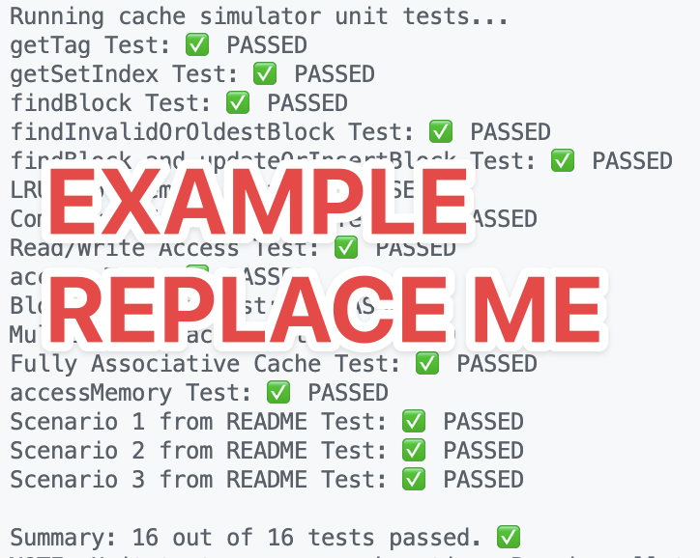

Task 1: Arrays and Linked Lists (42 points)
- Show a sample (screenshot) of each of the traces: (10 points)

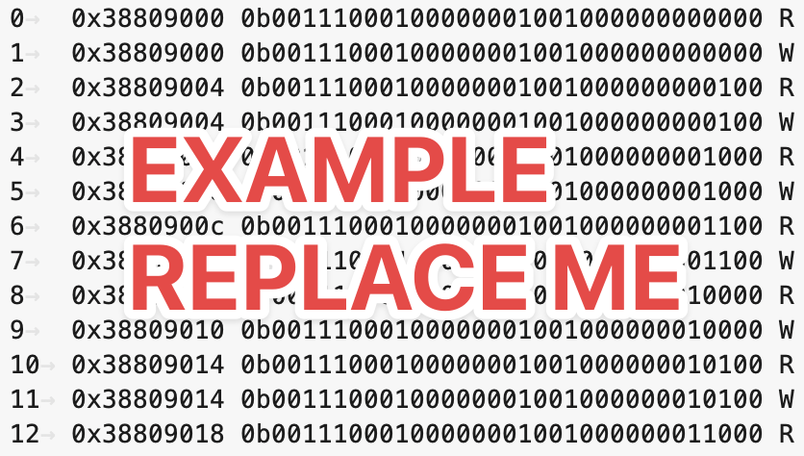

- For each configuration, show the simulator's performance metrics (screenshot): (10 points)

- For each workload, which configuration has the best performance in terms of total memory access time? (2 points)

- For each given configuration, which workload is more cache-friendly (i.e. has lower memory access time)? Why? (20 points)

Task 2: Steps and Set Associativity (42 points)
(a) Record the metrics of the cache simulator (screenshot): (2 points)

- Which workload finishes faster? Why is there a difference in performance? (10 points)

- For the slower workload, which configuration gives the best performance? Why? (10 points)

- For the slower workload, why do the remaining configurations perform worse? What bad things are happening? (10 points)

- What does this task tell you about the selection of set associativity? (10 points)

